Staying on top of your cash flow by getting paid on time
Cash is the life blood of any business. One way of staying on top of your cash flow is making sure your debtors pay invoices on time.
Sending out invoices on time
Send out invoices as soon as the work is completed or as soon as payment terms or claim schedules outline.
Be clear on your invoice:
- Which goods or services you are invoicing for
- What your payment terms are
- The amount owed and due date should be clearly displayed
- Provide your billing address and bank account details
- If possible, offer multiple payment methods
Often the person ordering the service or goods, is not the person paying the invoice. So it is important to get the right contact. In some cases an invoice needs a purchase order. Request information like this up front to avoid any delays.
Effective debtor management
Communication is key for effective debtor management.
What if someone has not paid by the due date? Having a process in place is crucial. For example, an email reminder two business days after the due date and a follow-up phone call if there is no response after a week. This process can vary from business to business.
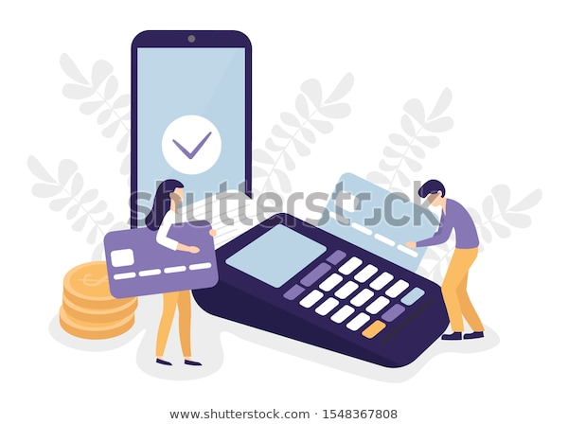
- Keep an accurate record of debtors and amount of debts owed
- Get in touch as soon as an invoice is overdue – it can be just a brief, friendly reminder via email or a phone call
- Set up templates for debtor management emails to save time
- Make sure you speak to the right person and get a payment date confirmed

If you need help with managing your cash flow, touch base with our team on 09 470 1840, accounting@ebp.co.nz or chat with us on Facebook.

